|  |
| --- |
| Predictive Health Notification  Alinity I Pipettor Syringe Backlash |
| ALINITY ci Immunoassay Analyzer  Anthony Schuler  June 25, 2018 |

**PHN - Alinity i Pipettor Syringe Backlash Spec Sheet for Apollo**

**References**

APLM ID D000047626/B PHN for Alinity I Syringe Backlash

**Summary**

To implement a Predictive Health Notification (PHN) algorithm for Alinity i Analyzers that will detect degrading syringe performance before the customer begins experiencing pipetting issues.

|  |  |
| --- | --- |
| PHN Descriptor | Alinity IA Pipettor Syringe Backlash |
| PHN Experience Code / Name | CC12: PHN_Alinity_IA; PHN_R1 Pipettor_IA; Syringe Backlash  CC22: PHN_Alinity_IA; PHN_R2 Pipettor_IA; Syringe Backlash  CCJ2: PHN_Alinity_IA; PHN_Sample Pipettor_IA; Syringe Backlash |
| PHN KM Article Number/ Name | K09702532 PHN_Alinity_IA Pipettor Syringe Backlash |
| Service Level | 2- Advanced Service |
| Always On Package | Always On 01DP5- 01, 02, 03, 09, 70, 80, 83, 84, 89 |
| IDA Table(s) | IDAQOWNER.ICQ_INSTRUMENTACTIVITY |
| IDA Table Fields | MODULESN, LOGDATE_LOCAL, ACTIVITY |
| Analysis Frequency | Daily |
| Data Required | Previous 1 day |
| Data Aggregation | Mean |
| Run Time Estimate | 54 seconds (31 days, 181 instruments, 3,358,629 rows, 15 algorithm flags) |
| Flag Criteria | Mean PosDiff (i.e. backlash) value > 95 |
| Probable Failure Modes | Internal spring in syringe becomes worn or out of specification |
| Suppression Experience Codes | No Suppression |
| Applicable Work Done Codes (WDC) | R1: CB**: Fluid Movement, R1 Syringe  R2: CC**: Fluid Movement, R2 Syringe  Sample: CA**: Fluid Movement, Sample Syringe |

**Data Processing Steps**

|  |  |
| --- | --- |
| Data Processing Steps | |
| 1 | Query all data from the previous day for each syringe/instrument combination (IDA Table: IDAQOWNER.ICQ_INSTRUMENTACTIVITY). |
| 2 | Unique syringes will be identified by PIPETTOR (parsed from the ACTIVITY field) and MODULESN. |
| 3 | Exclude syringes that have less than 5 data points. |
| 4 | Flag any syringe/instrument combination with a Mean PosDiff value (parsed from the ACTIVITY field) > 95. |
|  |  |

**Define Reusable Routine**

|  |  |
| --- | --- |
| **Routine Details** |  |
| Routine Source | Define Reusable Routine |
| Routine Type | Oracle Procedure |
| Run Mode | Batch |
| Routine Invoke Command | PHM_ICQ_Syringe_Backlash_PROC |
| Status | Disable |

|  |  |
| --- | --- |
| **Apollo Details** |  |
| Algorithm ID * | Alinity IA Pipettor Syringe Backlash - Generic |
| Algorithm Name * | Alinity IA Pipettor Syringe Backlash – Generic |
| Algorithm Description * | Reusable Routine for Alinity IA Pipettor Syringe Backlash algorithms. |
| Product Family * | Alinity IA |
| Algorithm Group * | Alinity Pipettor |
| Functional Area | N/A |
| Algorithm Category 1 | N/A |
| Algorithm Category 2 | N/A |
| Algorithm Category 3 | N/A |
| Remaining Useful Life Value | 7 |
| Remaining Useful Life Unit | Day |
| Keep Results Num Days | 14 |
| **Routine Details** |  |
| Routine Source | Define Reusable Routine |
| Routine Type | Oracle Procedure |
| Run Mode | Batch |
| Routine Invoke Command | PHM_ICQ_Syringe_Backlash_PROC |
| Status | Disable |
| **Parameters** |  |
| Parameter Group Name | ICQ_Pipettor_Syringe_Backlash |
| **Parameter Name** | **Parameter Values** |
| IHN_LEVEL3_DESC | IHN_LEVEL3_DESC |
| I_POSDIFF_THRESHOLD_ACTIVITY | SyringeCheckResult for pipettor: |
| I_POSDIFF_THRESHOLD_MAX | 95 |
| I_POSDIFF_THRESHOLD_NUMFLAGS | 1 |
| I_POSDIFF_THRESHOLD_NUMREPS | 5 |
| THRESHOLDS_COUNT | 1 |
| THRESHOLD_DESCRIPTION | THRESHOLD_DESCRIPTION |

**APPENDIX 1:** CCJ2: PHN_Alinity_IA; PHN_Sample Pipettor_IA; Syringe Backlash

**Algorithm Code**

SELECT

inner.MODULESN

FROM

(SELECT

IA.MODULESN,

COUNT(regexp_substr(IA.ACTIVITY,'\PosDiff:\s(.*?)\Z',1,1,null,1)) AS NUM_TESTS,

CASE WHEN AVG(regexp_substr(IA.ACTIVITY,'\PosDiff:\s(.*?)\Z',1,1,null,1)) > 95 THEN 1 ELSE 0 END AS FLAG

FROM

IDAQOWNER.ICQ_INSTRUMENTACTIVITY IA

WHERE

TRUNC(IA.LOGDATE_LOCAL) >= TRUNC(SYSDATE) - 1

AND TRUNC(IA.LOGDATE_LOCAL) < TRUNC(SYSDATE)

AND IA.ACTIVITY LIKE 'SyringeCheckResult for pipettor: SamplePipettor%'

GROUP BY

IA.MODULESN) inner

WHERE

inner.FLAG >= 1

AND inner.NUM_TESTS >= 5

**Apollo Algorithm Details**

(* is Mandatory)

|  |  |
| --- | --- |
| **Apollo Details** |  |
| Algorithm ID * | Alinity IA Pipettor Sample Syringe Backlash |
| Algorithm Name * | Alinity IA Pipettor Sample Syringe Backlash |
| Algorithm Description * | To detect degrading syringe performance before the customer begins to experience an increase in pipetting issues. |
| Product Family * | Alinity IA |
| Algorithm Group * | Alinity Pipettor |
| Functional Area | N/A |
| Algorithm Category 1 | N/A |
| Algorithm Category 2 | N/A |
| Algorithm Category 3 | N/A |
| Remaining Useful Life Value | 7 |
| Remaining Useful Life Unit | Day |
| Keep Results Num Days | 14 |
| **Routine Details** |  |
| Routine Source | Use Reusable Routine |
| Reusable Routines | Alinity IA Pipettor Syringe Backlash – Generic |
| Run Mode | Batch |
| Status | Enable |
| **ODS Routine Details** |  |
| ODS Routine Name | PHM_ODS_ICQ_ACTIVITY_PROC |
| **Predictive Health Notification Details** |  |
| PHN Code | PHN_Alinity IA_CCJ2 |
| Issue Description (Use Algorithm Name) |  |
| Experience Code | CCJ2 |
| **Knowledge Management DB Articles** |  |
| KM Article ID | K09702532 |
| KM Article | PHN_Alinity_IA Pipettor Syringe Backlash |
| **Parameters** |  |
| Parameter Group Name | ICQ_Pipettor_Syringe_Backlash |
| **Parameter Name** | **Parameter Values** |
| IHN_LEVEL3_DESC | Alinity IA Pipettor Sample Syringe Backlash |
| I_POSDIFF_THRESHOLD_ACTIVITY | SyringeCheckResult for pipettor: SamplePipettor% |
| I_POSDIFF_THRESHOLD_MAX | 95 |
| I_POSDIFF_THRESHOLD_NUMFLAGS | 1 |
| I_POSDIFF_THRESHOLD_NUMREPS | 5 |
| THRESHOLDS_COUNT | 1 |
| THRESHOLD_DESCRIPTION | Alinity IA Pipettor Sample Syringe Backlash |
| **Chart Details** |  |
| Chart Title | Alinity IA Pipettor Sample Syringe Backlash |
| Chart Type | Line |
| Chart Threshold Parameter | ICQ_Pipettor_Syringe_Backlash- THRESHOLD_COUNT |
| Group ID | Group 7 |
| Chart X Axis Name | Date |
| Chart Y Axis Name | Threshold Count |

**APPENDIX 2:** CC12: PHN_Alinity_IA; PHN_R1 Pipettor_IA; Syringe Backlash

**Algorithm Code**

SELECT

inner.MODULESN

FROM

(SELECT

IA.MODULESN,

COUNT(regexp_substr(IA.ACTIVITY,'\PosDiff:\s(.*?)\Z',1,1,null,1)) AS NUM_TESTS,

CASE WHEN AVG(regexp_substr(IA.ACTIVITY,'\PosDiff:\s(.*?)\Z',1,1,null,1)) > 95 THEN 1 ELSE 0 END AS FLAG

FROM

IDAQOWNER.ICQ_INSTRUMENTACTIVITY IA

WHERE

TRUNC(IA.LOGDATE_LOCAL) >= TRUNC(SYSDATE) - 1

AND TRUNC(IA.LOGDATE_LOCAL) < TRUNC(SYSDATE)

AND IA.ACTIVITY LIKE 'SyringeCheckResult for pipettor: R1Pipettor%'

GROUP BY

IA.MODULESN) inner

WHERE

inner.FLAG >= 1

AND inner.NUM_TESTS >= 5

**Apollo Algorithm Details**

(* is Mandatory)

|  |  |
| --- | --- |
| **Apollo Details** |  |
| Algorithm ID * | Alinity IA Pipettor R1 Syringe Backlash |
| Algorithm Name * | Alinity IA Pipettor R1 Syringe Backlash |
| Algorithm Description * | To detect degrading syringe performance before the customer begins to experience an increase in pipetting issues. |
| Product Family * | Alinity IA |
| Algorithm Group * | Alinity Pipettor |
| Functional Area | N/A |
| Algorithm Category 1 | N/A |
| Algorithm Category 2 | N/A |
| Algorithm Category 3 | N/A |
| Remaining Useful Life Value | 7 |
| Remaining Useful Life Unit | Days |
| Keep Results Num Days | 14 |
| **Routine Details** |  |
| Routine Source | Use Reusable Routine |
| Reusable Routines | Alinity IA Pipettor Syringe Backlash - Generic |
| Run Mode | Batch |
| Status | Enable |
| **ODS Routine Details** |  |
| ODS Routine Name | PHM_ODS_ICQ_ACTIVITY_PROC |
| **Predictive Health Notification Details** |  |
| PHN Code | PHN_Alinity IA_CC12 |
| Issue Description (Use Algorithm Name) |  |
| Experience Code | CC12 |
| **Knowledge Management DB Articles** |  |
| KM Article ID | K09702532 |
| KM Article | PHN_Alinity_IA Pipettor Syringe Backlash |
| **Parameters** |  |
| Parameter Group Name | ICQ_Pipettor_Syringe_Backlash |
| **Parameter Name** | **Parameter Values** |
| IHN_LEVEL3_DESC | Alinity IA Pipettor R1 Syringe Backlash |
| I_POSDIFF_THRESHOLD_ACTIVITY | SyringeCheckResult for pipettor: R1Pipettor% |
| I_POSDIFF_THRESHOLD_MAX | 95 |
| I_POSDIFF_THRESHOLD_NUMFLAGS | 1 |
| I_POSDIFF_THRESHOLD_NUMREPS | 5 |
| THRESHOLDS_COUNT | 1 |
| THRESHOLD_DESCRIPTION | Alinity IA Pipettor R1 Syringe Backlash |
| **Chart Details** |  |
| Chart Title | Alinity IA Pipettor R1 Syringe Backlash |
| Chart Type | Line |
| Chart Threshold Parameter | ICQ_Pipettor_Syringe_Backlash- THRESHOLD_COUNT |
| Group ID | Group 7 |
| Chart X Axis Name | Date |
| Chart Y Axis Name | Threshold Count |

**APPENDIX 3:** CC22: PHN_Alinity_IA; PHN_R2 Pipettor_IA; Syringe Backlash

**Algorithm Code**

SELECT

inner.MODULESN

FROM

(SELECT

IA.MODULESN,

COUNT(regexp_substr(IA.ACTIVITY,'\PosDiff:\s(.*?)\Z',1,1,null,1)) AS NUM_TESTS,

CASE WHEN AVG(regexp_substr(IA.ACTIVITY,'\PosDiff:\s(.*?)\Z',1,1,null,1)) > 95 THEN 1 ELSE 0 END AS FLAG

FROM

IDAQOWNER.ICQ_INSTRUMENTACTIVITY IA

WHERE

TRUNC(IA.LOGDATE_LOCAL) >= TRUNC(SYSDATE) - 1

AND TRUNC(IA.LOGDATE_LOCAL) < TRUNC(SYSDATE)

AND IA.ACTIVITY LIKE 'SyringeCheckResult for pipettor: R2Pipettor%'

GROUP BY

IA.MODULESN) inner

WHERE

inner.FLAG >= 1

AND inner.NUM_TESTS >= 5

**Apollo Algorithm Details**

(* is Mandatory)

|  |  |
| --- | --- |
| **Apollo Details** |  |
| Algorithm ID * | Alinity IA Pipettor R2 Syringe Backlash |
| Algorithm Name * | Alinity IA Pipettor R2 Syringe Backlash |
| Algorithm Description * | To detect degrading syringe performance before the customer begins to experience an increase in pipetting issues. |
| Product Family * | Alinity IA |
| Algorithm Group * | Alinity Pipettor |
| Functional Area | N/A |
| Algorithm Category 1 | N/A |
| Algorithm Category 2 | N/A |
| Algorithm Category 3 | N/A |
| Remaining Useful Life Value | 7 |
| Remaining Useful Life Unit | Day |
| Keep Results Num Days | 14 |
| **Routine Details** |  |
| Routine Source | Use Reusable Routine |
| Reusable Routines | Alinity IA Pipettor Syringe Backlash - Generic |
| Run Mode | Batch |
| Status | Enable |
| **ODS Routine Details** |  |
| PHM_ODS_ICQ_ACTIVITY_PROC | PHM_ODS_ICQ_ACTIVITY_PROC |
| **Predictive Health Notification Details** |  |
| PHN Code | PHN_Alinity IA_CC22 |
| Issue Description (Use Algorithm Name) |  |
| Experience Code | CC22 |
| **Knowledge Management DB Articles** |  |
| KM Article ID | K09702532 |
| KM Article | PHN_Alinity_IA Pipettor Syringe Backlash |
| **Parameters** |  |
| Parameter Group Name | ICQ_Pipettor_Syringe_Backlash |
| **Parameter Name** | **Parameter Values** |
| IHN_LEVEL3_DESC | Alinity IA Pipettor R2 Syringe Backlash |
| I_POSDIFF_THRESHOLD_ACTIVITY | SyringeCheckResult for pipettor: R2Pipettor% |
| I_POSDIFF_THRESHOLD_MAX | 95 |
| I_POSDIFF_THRESHOLD_NUMFLAGS | 1 |
| I_POSDIFF_THRESHOLD_NUMREPS | 5 |
| THRESHOLDS_COUNT | 1 |
| THRESHOLD_DESCRIPTION | Alinity IA Pipettor R2 Syringe Backlash |
| **Chart Details** |  |
| Chart Title | Alinity IA Pipettor R2 Syringe Backlash |
| Chart Type | Line |
| Chart Threshold Parameter | ICQ_Pipettor_Syringe_Backlash- THRESHOLD_COUNT |
| Group ID | Group 7 |
| Chart X Axis Name | Date |
| Chart Y Axis Name | Threshold Count |

**APPENDIX 4:** Algorithm Understanding Check – Algorithm Developer to Predictive Health Monitoring (PHM) Specialist Transition

**Data Set Description**

The data set for this understanding check was retrieved from the ICQOWNER.ODR_INSTRUMENTACTIVITYICQ table within the BSQD1I database. Data was collected for all instruments between October 1, 2017 and October 31, 2017, inclusive. Data collection was limited to the MODULESN, LOGDATE, and ACTIVITY fields.

**Data Set Retrieval**

The following SQL code was used to retrieve the data set:

SELECT

IA.MODULESN,

IA.LOGDATE,

IA.ACTIVITY

FROM

ICQOWNER.ODR_INSTRUMENTACTIVITYICQ IA

WHERE

TRUNC(IA.LOGDATE) >= TO_DATE('10/01/2017 12:00:00 AM', 'mm/dd/yyyy hh:mi:ss am')

AND TRUNC(IA.LOGDATE) < TO_DATE('11/01/2017 12:00:00 AM', 'mm/dd/yyyy hh:mi:ss am')

**Algorithm Developer Analysis**

The following JMP code and processing steps were used by the Algorithm Developer to analyze the data set and flag algorithm violations:

1) Used JMP 13 query builder to query BSD1I ICQOWNER.ODR_INSTRUMENTACTIVITYICQ table between 10/01/17 and 10/31/17 for all rows containing “Syringe” in the ACTIVITY column.

2) Used “text to columns” function to parse the ACTIVITY text column containing the backlash data.

3) Selected rows where the Mean Diff was greater than 95.

4) Summarized the days with rows exceeding the threshold by instrument (2 days on one instrument).

**PHM Specialist Analysis**

The following SQL code was used by the PHM Specialist to analyze the data set and flag algorithm violations:

SELECT

inner.*

FROM

(SELECT

IA.MODULESN,

TRUNC(IA.LOGDATE) AS DAY,

regexp_substr(IA.ACTIVITY,'\pipettor:\s(.*?)\,',1,1,null,1) AS PIPETTOR,

COUNT(regexp_substr(IA.ACTIVITY,'\PosDiff:\s(.*?)\Z',1,1,null,1)) AS NUM_TESTS,

AVG(regexp_substr(IA.ACTIVITY,'\PosDiff:\s(.*?)\Z',1,1,null,1)) AS MEAN_BLDIFF,

CASE WHEN AVG(regexp_substr(IA.ACTIVITY,'\PosDiff:\s(.*?)\Z',1,1,null,1)) > 95 THEN 1 ELSE 0 END AS FLAG

FROM

ICQOWNER.ODR_INSTRUMENTACTIVITYICQ IA

WHERE

TRUNC(IA.LOGDATE) >= TO_DATE('10/01/2017 12:00:00 AM', 'mm/dd/yyyy hh:mi:ss am')

AND TRUNC(IA.LOGDATE) < TO_DATE('11/01/2017 12:00:00 AM', 'mm/dd/yyyy hh:mi:ss am')

AND IA.ACTIVITY LIKE 'SyringeCheckResult for pipettor:%'

GROUP BY

IA.MODULESN,

TRUNC(IA.LOGDATE),

regexp_substr(IA.ACTIVITY,'\pipettor:\s(.*?)\,',1,1,null,1)) inner

WHERE

inner.FLAG >= 1

AND inner.NUM_TESTS >= 5

**Algorithm Developer Analysis Output**

The following 15 instrument (MODULESN), day (Date[LOGDATE]), pipettor combinations were identified as violating the algorithm by the Algorithm Developer:

|  |  |  |  |  |  |
| --- | --- | --- | --- | --- | --- |
| Date[LOGDATE] | MODULESNDRM | MODULESN | Pipettor | N Rows | Mean(Diff) |
| 10/16/2017 | IAVP21 | IV00021 | R2Pipettor | 25 | 147.72 |
| 10/16/2017 | IAVP29 | IV00029 | R1Pipettor | 25 | 162.16 |
| 10/17/2017 | IAVP21 | IV00021 | R2Pipettor | 40 | 127.75 |
| 10/18/2017 | IAVP21 | IV00021 | R2Pipettor | 20 | 158.15 |
| 10/22/2017 | IAVP21 | IV00021 | R2Pipettor | 55 | 102.67272727 |
| 10/23/2017 | IAVP21 | IV00021 | R2Pipettor | 65 | 153.41538462 |
| 10/23/2017 | IAVP29 | IV00029 | R1Pipettor | 25 | 127.36 |
| 10/24/2017 | IAVP21 | IV00021 | R2Pipettor | 45 | 122.6 |
| 10/24/2017 | IAVP29 | IV00029 | R1Pipettor | 5 | 143.2 |
| 10/26/2017 | IAVP21 | IV00021 | R2Pipettor | 20 | 114.65 |
| 10/26/2017 | SCM01173 | Ai01089 | R2Pipettor | 25 | 125.92 |
| 10/27/2017 | IAVP29 | IV00029 | R1Pipettor | 5 | 170.6 |
| 10/27/2017 | SCM01173 | Ai01089 | R2Pipettor | 40 | 121.3 |
| 10/30/2017 | SCM01173 | Ai01089 | R2Pipettor | 45 | 121.08888889 |
| 10/31/2017 | IAVP21 | IV00021 | R2Pipettor | 20 | 169.7 |

**PHM Specialist Analysis Output**

The following 15 instrument (MODULESN), day (DAY), syringe (PIPETTOR) combinations were identified as violating the algorithm by the PHM Specialist:

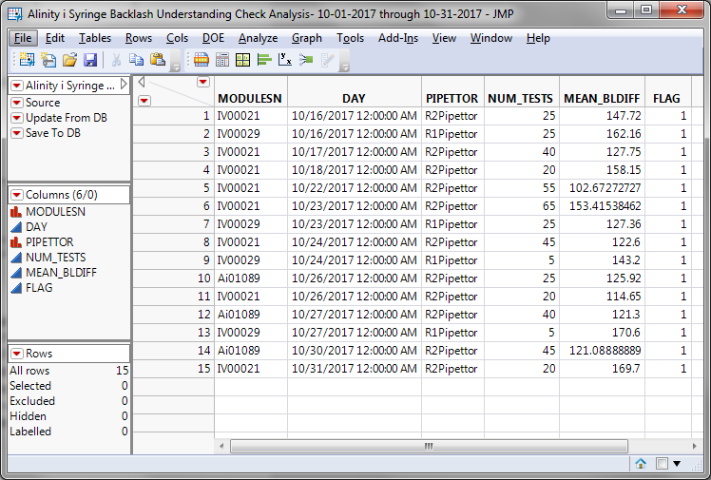

**Algorithm Developer & PHM Specialist Output Comparison**

|  |  |  |  |
| --- | --- | --- | --- |
| Total # of Unique Instrument-Part-Days Tested | Total # of Algorithm Developer Flags | Total # of PHM Specialist Flags | Total # of Matched Flags (Algorithm Developer vs. PHM Specialist) |
| **2,303** | **15** | **15** | **15** |

**Understanding Check Summary**

Based on the outputs from both the Algorithm Developer and PHN Specialist, the PHN Specialist’s understanding of the delivered algorithm is confirmed. Both the Algorithm Developer and PHN Specialist analyzed the same data set and got the same results. In particular, the MODULESN, Date[LOGDATE]/DAY, Pipettor/PIPETTOR, N Rows/NUM_TESTS and Mean(Diff)/MEAN_BLDIFF fields matched for all 15 instrument-part-day (MODULESN-Pipettor//PIPETTOR- Date[LOGDATE]/DAY) combinations. This means that both the Algorithm Developer and PHN Specialist flagged the same 15 algorithm violations within the given data set. Furthermore, there were no mismatches between the output from the Algorithm Developer and the output from the PHM Specialist.

**APPENDIX 5:** Algorithm Transition to Apollo – PHM Specialist to Apollo Developer

**Data Set Description**

The data set for this transition was retrieved from the IDAQOWNER.ICQ_INSTRUMENTACTIVITY table within the DABBTO database. Data was collected for all available instruments between June, 14 2018 and June 15, 2018, inclusive.

**PHM Specialist Analysis Output**

The following 2 instrument-days (MODULESN-DAY) were identified as violating the algorithm by the PHM Specialist:

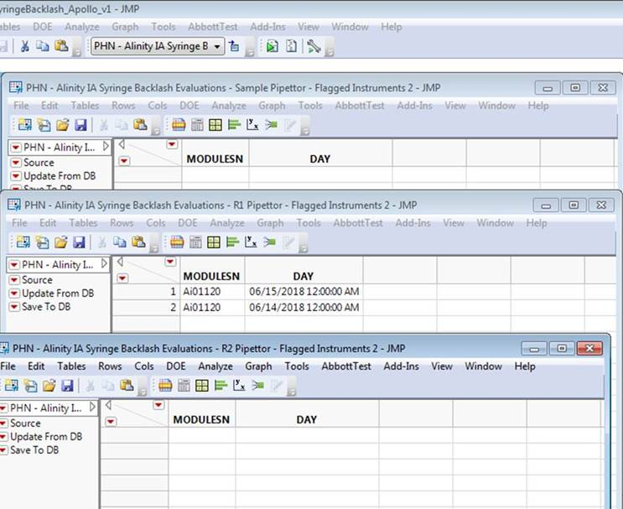

**Apollo Developer Analysis Output**

The following 2 instrument-days (SN-FLAG_DATE) were identified as violating the algorithm by the Apollo Developer:

Sample Pipettor:

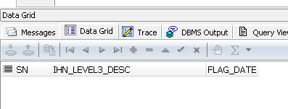

R1 Pipettor:

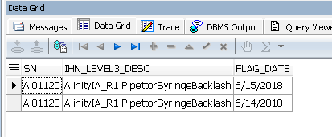

R2 Pipettor:

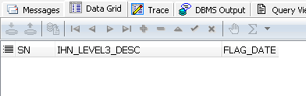

**Algorithm Transition Summary**

Based on the outputs from both the Apollo Developer and PHM Specialist, the Apollo Developer’s understanding of the delivered algorithm is confirmed. Both the Apollo Developer and PHM Specialist analyzed the same data set and got the same results. In particular, the MODULESN/SN and DAY/FLAG_DATE fields matched by pipettor (i.e. Sample, R1, R2). This means that both the Apollo Developer and PHM Specialist flagged the same algorithm violations within the given data set.